UTAH ROSE SOCIETY
Announces the annual rose show

“A Year of Roses”

Saturday, June 11, 2016
12:00 noon to 4:00 PM

Sugarhouse Park Garden Center
1602 East 2100 South

Come and see the display of beautiful roses of all varieties.

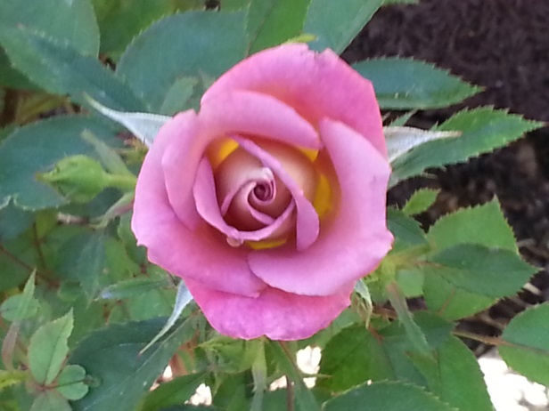

The Utah Rose Society meets at Sugarhouse Park Garden Center the third Thursday of every month (unless otherwise indicated) at 6:30 PM. For more information, please visit the web site at www.utah-rose-society.com.
The web site offers information about everything you need to know about rose culture and growing, what to do in the garden each month, how to join the Utah Rose Society, rose links, and much more! Check it out!

Please join us! Everyone is welcome.

Questions? Contact Elise Hutchings at 801-484-1156
or elisehut1@aol.com

